Day 3 : 14 September 2024

Spring JDBC or DAO layer

Spring DAO provided pre defined class ie JdbcTemplate. This class wrap core Jdbc code. It provided set of method which help to improve jdbc code.

RowMapper is a type of interface provide spring jdbc module which help to map record to object. it is a type of functional interface.

Spring MVC : This module mainly use to improve web application.

Limitation of servlet.

If we want to create servlet program we need to create normal java class and that class must be implement type of servlet ie Servlet, GenericServlet and HttpServlet

Class MyServlet extends HttpServlet {

public void doGet(HttpServletRequest req, HttpServletResponse res) {

}

public void doPost(HttpServletRequest req, HttpServletResponse res) {

}

}

Insider doGet, doPost, doPut , doDelete these all method contains two parameter ie request and response. If we are not using request or response object still those object present in each methods.

If we need in one servlet more than one doGet or doPost. We can’t create.

This servlet is known as heavy class because this class extends type of servlet. So all method part of servlet inherits by default.

In Spring MVC : ModelAndView pre defined class provided by spring mvc module. Controller is intermediate between model and view. This class hold model and view layer information.

@RequestMapping annotation is use to map the request like url pattern part of web.xml file in servlet application.

@Controller this class behave like Servlet.

class MyController {

@RequestMapping(value=”hello”,method=ReuqestedMethod.GET)

public ModelAndView sayHello() {

// coding….

ModelAndView mav = new ModelAndView();

mav.setViewName(“display1.jsp”);

return mav;

}

@RequestMapping(value=”hi”,method=ReuqestedMethod.GET)

public ModelAndView sayHi(HttpServletRequest req) { // DI for request object.

// coding….

ModelAndView mav = new ModelAndView();

mav.setViewName(“display2.jsp”);

return mav;

}

}

Creating Simple Spring MVC App

Create dynamic web project with below options.

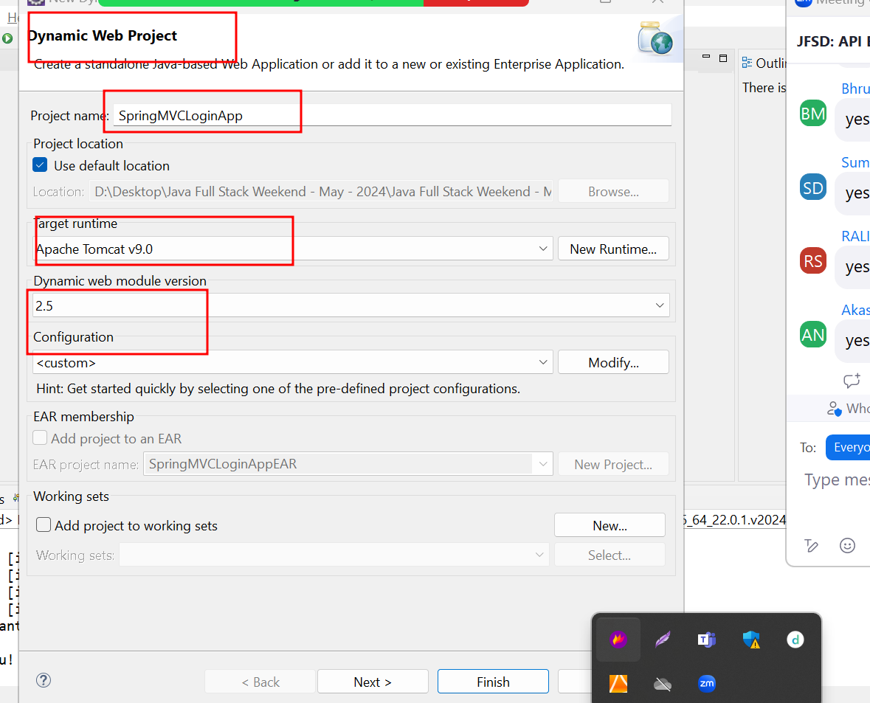

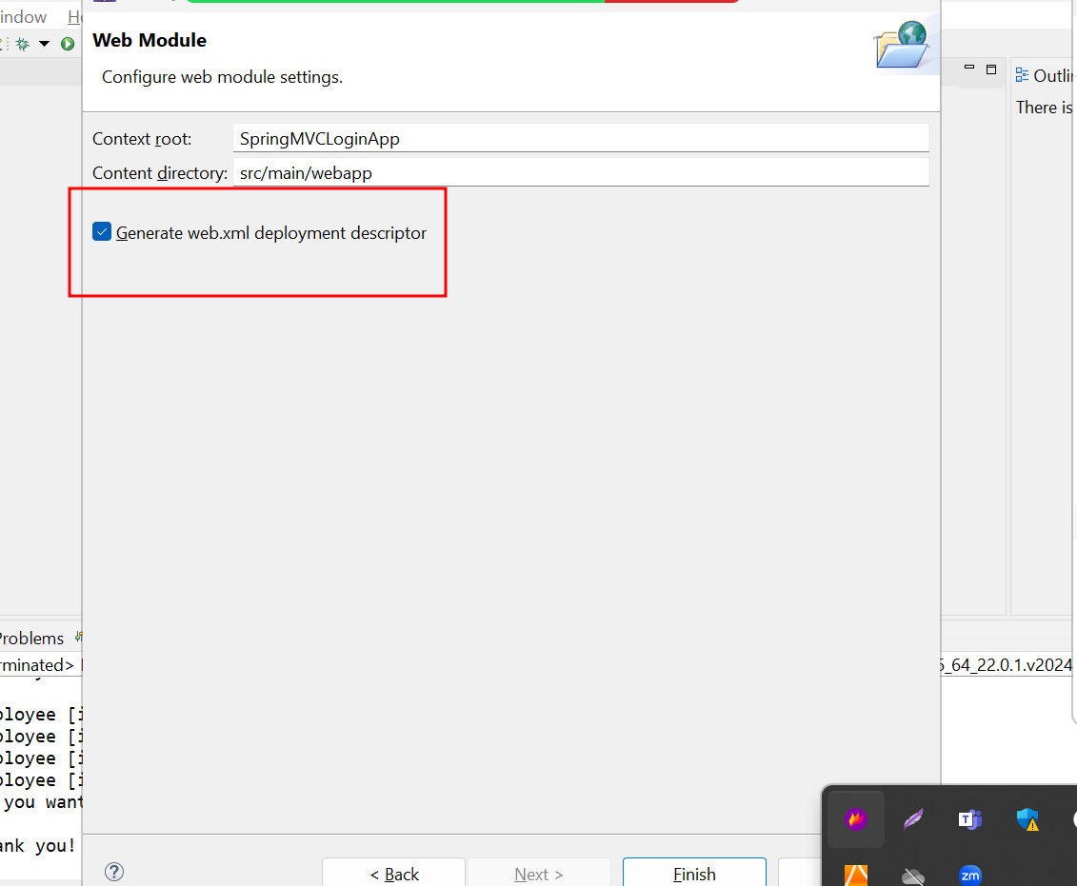

Now we need to convert this project to maven project. Which provide pom.xml file to add dependencies.

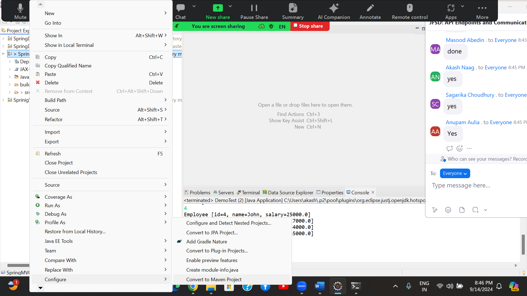

Spring mvc internally follow MVC design pattern as well as FrontController design pattern.

FrontController control all sub controller of the application.

Spring MVC internally provided one of pre defined class ie DispatcherServlet. Which behave like a front controller.

This class we can configure in web.xml or class with @Configuration.

<servlet>

<servlet-name>dispatcher</servlet-name>

<servlet-class>org.springframework.web.servlet.DispatcherServlet</servlet-class>

</servlet>

<servlet-mapping>

<servlet-name>dispatcher</servlet-name>

<url-pattern>/</url-pattern>

</servlet-mapping>

In xml file we written url-pattern as /. Means any request can pass to DispatcherServlet. Once request receive it will check spring configuration file start with prefix as servlet name part of <servlet-name> tag followed by

-servet.xml

Example

dispatcher-servlet.xml

abc-servlet.xmlf

this file must be inside WEB-INF folder.